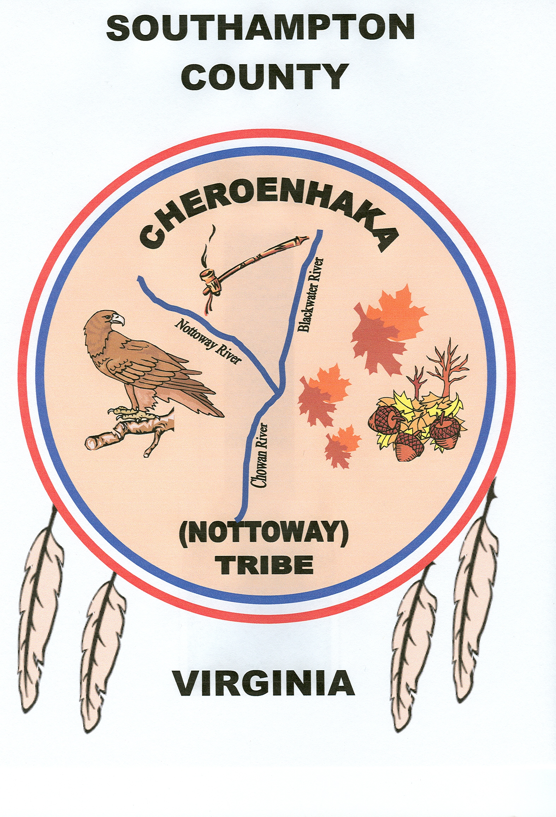
CHEROENHAKA (NOTTOWAY) INDIAN TRIBE
Ruth B. Campbell Library, Franklin, VA

February 11, 2017

SUBJECT: Tribal Council/ Foundation Business Meeting Agenda

DRAFT AGENDA

- Open Meeting with Iroquois Prayer / My Heart Song (Tribal Dar-sunke)
- Roll Call / Read and approve Minutes from last meeting (Jan 14, 2017 & note corrections)
- Old Business:
- Treasure’s Report: Membership / payment of administrative dues - status. Tribal and Heritage Foundation Bank account balance on hand?
- Turn In Dues/ Land Tax ./ Donations to FD Treasure
  - Last Deposits Made To Heritage FD Bank Acct ____________?
- Bills:
  - Mortgage Payment – $ 3,700.52 (Due Aug 2017 (Balance on Note $ 13,646.20
  - Roanoke Porta-Johns Payment Due : $350.00?
  - Mackans Office Supply Payment Due
  - Dominion Power Electric (Tribal Land) Payment Due: $92.02 & $92.66
  - New Tribal Land Real Estate Taxes (PAID) : TP 75-12 & 12 C: $1,376.78
New Business:
- Mail Letter To all tribal members Reference Dues and Land Tax – 35 Returned
- Review Tribal Rolls earmarking those that have not participated in the tribe for the past 6-10 years….Status Update (T. Baxter and T. Preston).
- Double Sided ID Card Maker - $3800 ( Need to Purchase Now)
- Update on First Nations Prayer Breakfast – Trump Tower Hotel, Jan 20
  - Native American Revival – Crusade for Christ (The Great Awaking of the Holy Spirit ), May 13, 2017 (Chief Steve Silverheels, Evangelist, Guest Preacher)
- AIFFVA 3 day meeting in Richmond VA – met with Gov of VA – Day view Nov 17 – 19, 2017 Historic Byrd Theater – Need Tribal Talent
- VA Tech’s Tribal Summit - Honoring the creation of their American Indian Community Center – March 15 – 16, 2017.
- Primitive Skills Gathering May 19 – 21, 2017 (BBQ Fundraiser????)
- New Tribal Members Enrollment Letter To Be Sent – How many sent???
- VDOT Land Condemnation – TP 75-14 & 75-12C (Deed of Correction Finalized)
- Dominion Power Electricity Bill Average Approx & 185.00 per Month – Need Own lights with Cut off Switch (Cost??)
- CN Tribal Heritage Foundation Website (on going – Thanks SBA and Three Crows)
- Coordinate Recording of Spoken Language CD
- Goggle Map of Tribal Land – Thanks Snow Lizard
- Networked and met Representatives from the Univ of Health Sciences Antigua and the McPherson Square Business Council – Tribal 8a Ongoing
- A Letter to be sent to the President Trump requesting Federal Recognition -Approval.
- Follow up: All Foundation Solicitations Request must include the following statement: “A Financial Statement is Available upon Request from the office of Charitable Contributions.”
- Revisit 2017 Goals and Objectives – Appoint Committees

- Close our meeting with prayer

